

**UNIVERSITY OF PETROLEUM & ENERGY STUDIES**

**Dehradun**

ACO LAB

# NAME- RADHIKA RAJESH THAKKAR

**BRANCH- COMPUTER SCIENCE ENGINEERING BATCH- B-4 DEVOPS**

# SAP ID- 500098212 ROLL NO- R2142211496

**SUBMITTED TO- Dr. Hitesh Kumar Sharma**

**EXPERIMENT -6**

# AIM : Working with Docker Compose File to Control Multiple Containers

**Steps to Complete:**

1. **Creating compose files**

· Create a directory named nginx in your root.

**“ mkdir nginx ”**

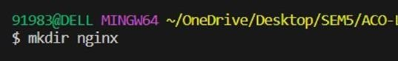

* Switch to that directory and create a file named docker-compose.yaml

**“ cd nginx ”**



**“ vi docker-compose.yml ”**

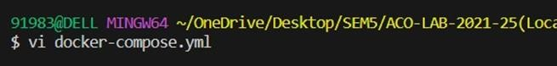

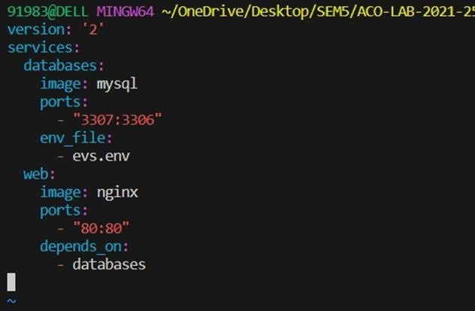

* Use docker-compose “version 2” to create docker-compose.yaml file.
* Create a service named "databases". Use image named "mysql"
* Map container 3306 port to host machine 3307 port.
* Add environment variables named "MYSQL_ROOT_PASSWORD", "MYSQL_DATABASE", "MYSQL_USER" and "MYSQL_PASSWORD" along with corresponding values for all.

## “ cat evs.env ”

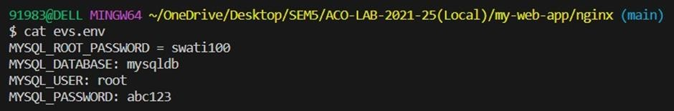

* Add another service named "web"
* Use image "nginx"

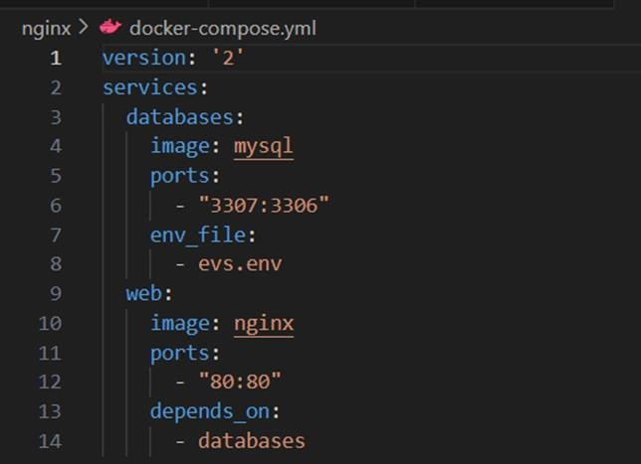

## Running images using docker-compose

* + Save docker-compose.yaml file and do “ docker-compose up ” .

## “ docker-compose up -d ”

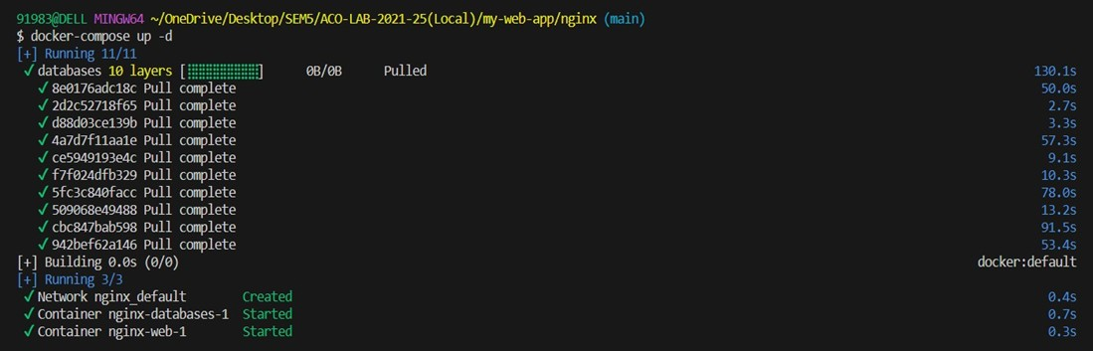

* + Verify nginx service is up and is accessible on machine.

## “ curl localhost:80 ”

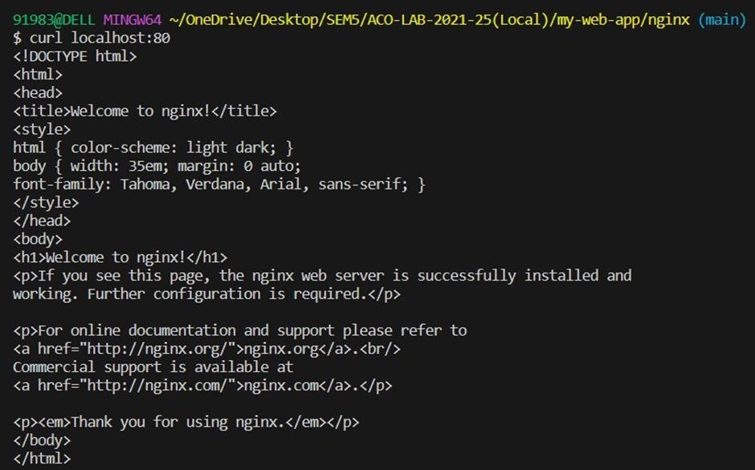

* + Stop and remove your docker container using docker-compose.

## “ docker-compose down ”

